

**<<Project name>>**

**Software Design Document**

– Hanoi, August 2019 –

**Table of Contents**

I. Overview 3

1. Code Packages 3

2. Database Schema 3

II. Code Designs 4

1. <Feature/Function Name1> 4

a. Class Diagram 4

b. Class Specifications 4

c. Sequence Diagram(s) 4

d. Database queries 5

2. <Feature/Function Name2> 5

III. Database Tables 5

1. <Table name 1> 5

2. <Table name 2…> 5

# I. Overview

## 1. Code Packages/Namespaces

*[Provide the package diagram for each sub-system. The content of this section including the overall package diagram, the explanation, package and class naming conventions in each package. Please see the sample and description table format below – following Java project naming convention]*

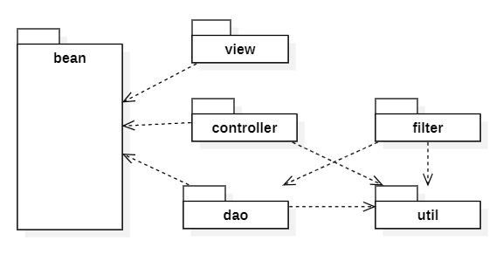

***Package descriptions & package class naming conventions***

|  |  |  |
| --- | --- | --- |
| **No** | **Package** | **Description** |
| *01* | *<Package name>* | *<Description of the package>*  *<Class naming convention>* |
| *02* |  |  |

## 2. Database Design

**2.1 Database Schema**

*[Provide the tables relationship like example below – following MySQL database naming convention]*

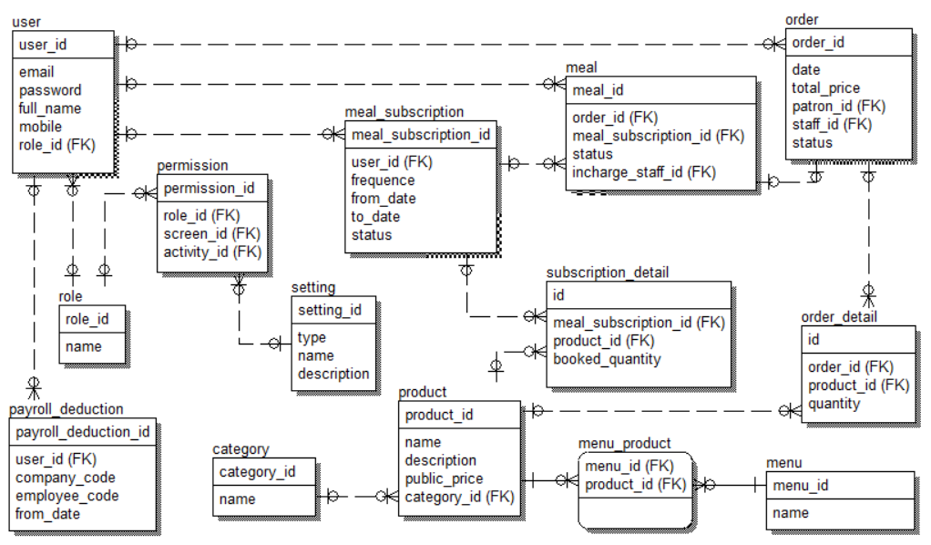

***Table descriptions & package class naming conventions are as below***

|  |  |  |
| --- | --- | --- |
| **No** | **Table** | **Description** |
| *01* | *<Table name>* | *<Description of the table>*  *- Primary keys: <<list of primary key fields>>*  *- Foreign keys: <<list of foreign key fields>>* |
| *02* |  |  |
|  |  |  |

**2.2 Database table**

## 1. <Table name 1>

*[Give some lines about the table here>>*

*[Table fields, in the form of table format as below]*

|  |  |  |  |  |  |  |  |
| --- | --- | --- | --- | --- | --- | --- | --- |
| **#** | **Field name** | **Type** | **Size** | **Unique** | **Not Null** | **PK/FK** | **Notes** |
| 1 | Field name1 |  |  |  |  |  |  |
| 2 | Field name2 |  |  |  |  |  |  |

## 2. <Table name 2…>

# II. Code Designs

## 1. My Car

### a. Screen Design

**Table 1:** **My Car Definition**

|  |  |  |  |  |  |
| --- | --- | --- | --- | --- | --- |
| **No** | **Object/Control Name** | **Type** | **Required** | **Length** | **Description** |
| 1 | Back | Button | Yes |  | Display by icon left arrow |
| 2 | Screen name | Text | Yes | 20 |  |
| 3 | Add new car | Button | Yes |  | Display by icon plus |
| 4 | Car item | Button |  |  | Display car’s basic information |

### b. Class Diagram

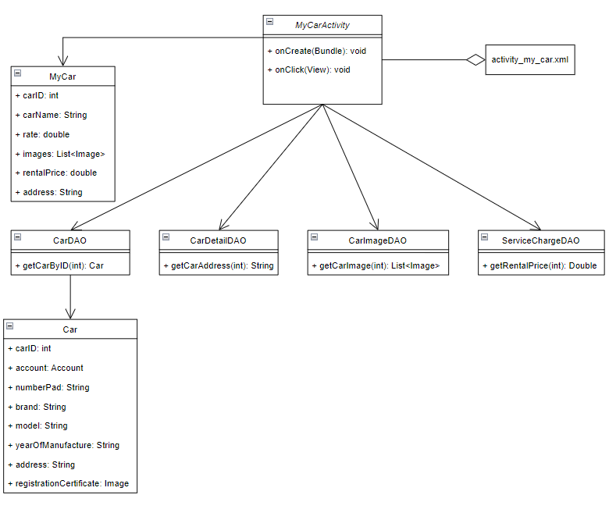

### c. Class Specifications

#### MyCarActivity

|  |  |  |
| --- | --- | --- |
| **No** | **Method** | **Description** |
| *01* | *onCreate()* |  |
| *02* | *onClick()* |  |

#### CarDAO

|  |  |  |
| --- | --- | --- |
| **No** | **Method** | **Description** |
| *01* | *getCarByID()* | *Get the car from database by its id* |

#### CarDetailDAO

|  |  |  |
| --- | --- | --- |
| **No** | **Method** | **Description** |
| *01* | *getCarAddress()* | *Get address information of the car by car’s id* |

#### CarImageDAO

|  |  |  |
| --- | --- | --- |
| **No** | **Method** | **Description** |
| *01* | *getCarImage()* | *Get all images of the car from database by car’s id* |

#### ServiceChargeDAO

|  |  |  |
| --- | --- | --- |
| **No** | **Method** | **Description** |
| *01* | *getRentalPrice()* | *Get rental price of the car by car’s id* |

### d. Sequence Diagram(s)

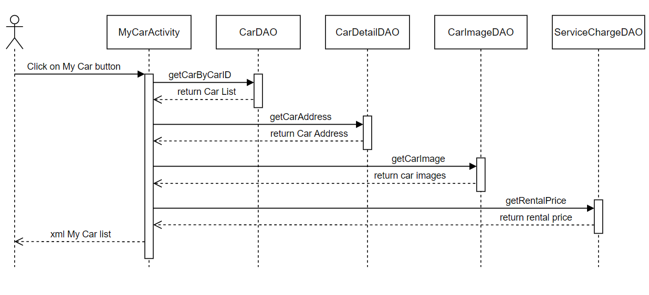

### e. Database queries

*- select * from Car where carID = ?*

*- select address from CarDetail where carID = ?*

*- select * from CarImage where carID = ?*

*- select retal_price from ServiceCharge where carID = ?*

## 2. Car Information

### a. Screen Design

**Table 2:** **Car Information Definition**

|  |  |  |  |  |  |
| --- | --- | --- | --- | --- | --- |
| **No** | **Object/Control Name** | **Type** | **Required** | **Length** | **Description** |
| 1 | Back | Button | Yes |  | Display by icon left arrow |
| 2 | Screen name | Text | Yes | 20 |  |
| 3 | Image | Button | Yes |  |  |
| 4 | Previous | Button |  |  |  |
| 5 | Next | Button |  |  |  |
| 6 | Name | Button |  |  |  |
| 7 | Rental price | Text |  | 10 |  |
| 8 | Address | Text |  | 50 |  |
| 9 | Seat | Text |  | 2 |  |
| 10 | Door | Text |  | 2 |  |
| 11 | Fuel | Text |  | 20 |  |
| 12 | Transmission | Text |  | 20 |  |
| 13 | Body style | Text |  | 20 |  |
| 14 | Drivetrain | Text |  | 20 |  |
| 15 | Description | Text |  | 200 |  |
| 16 | Feature | Icon |  |  |  |

### b. Class Diagram

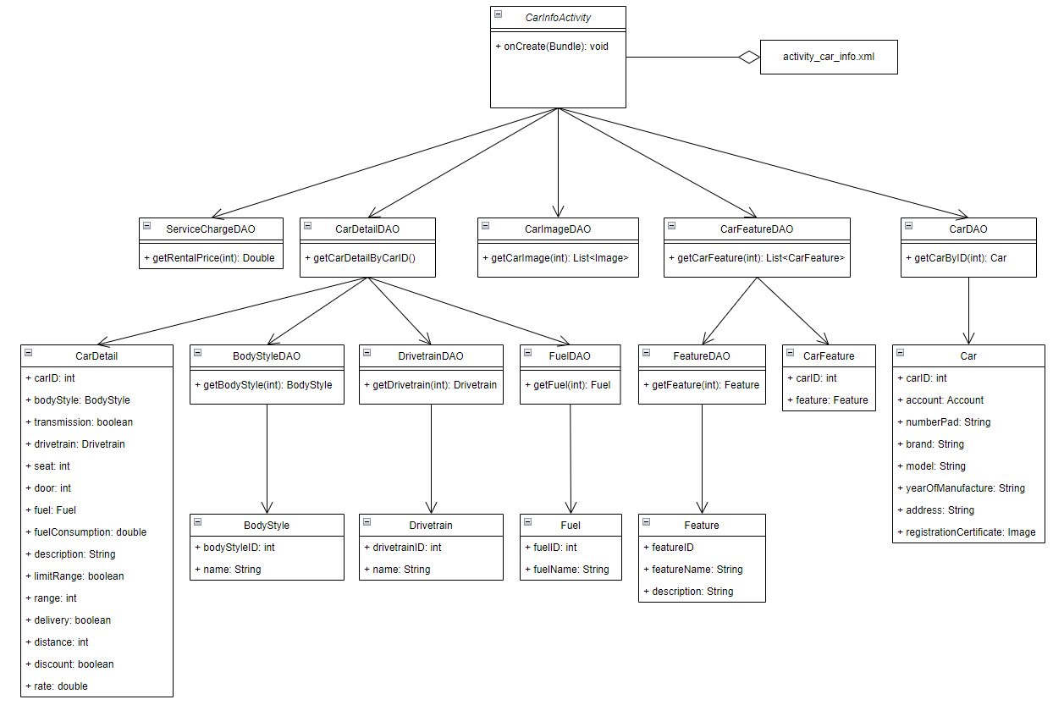

### c. Class Specifications

#### CarInformationActivity

|  |  |  |
| --- | --- | --- |
| **No** | **Method** | **Description** |
| *01* | *onCreate()* |  |
|  |  |  |

#### CarDetailDAO

|  |  |  |
| --- | --- | --- |
| **No** | **Method** | **Description** |
| *01* | *getCarDetailByCarID()* | *Get all details information of the car by its id* |
|  |  |  |

#### CarImageDAO

|  |  |  |
| --- | --- | --- |
| **No** | **Method** | **Description** |
| *01* | *getCarImage()* | *Get all images of the car from database* |
|  |  |  |

#### CarDAO

|  |  |  |
| --- | --- | --- |
| **No** | **Method** | **Description** |
| *01* | *getCarByCarID()* | *Get the car from database by its id* |
|  |  |  |

#### CarFeatureDAO

|  |  |  |
| --- | --- | --- |
| **No** | **Method** | **Description** |
| *01* | *getCarFeature()* | *Get the list of features of the car* |
|  |  |  |

#### ServiceChargeDAO

|  |  |  |
| --- | --- | --- |
| **No** | **Method** | **Description** |
| *01* | *getRentalPrice()* | *Get rental price of the car* |
|  |  |  |

#### BodyStyleDAO

|  |  |  |
| --- | --- | --- |
| **No** | **Method** | **Description** |
| *01* | *getBodyStyle()* | *Get body style of the car* |
|  |  |  |

#### DrivetrainDAO

***Class Methods***

|  |  |  |
| --- | --- | --- |
| **No** | **Method** | **Description** |
| *01* | *getDrivetrain()* | *Get drivetrain of the car* |
|  |  |  |

#### FuelDAO

***Class Methods***

|  |  |  |
| --- | --- | --- |
| **No** | **Method** | **Description** |
| *01* | *getFuel()* | *Get fuel type of the car* |
|  |  |  |

#### FeatureDAO

***Class Methods***

|  |  |  |
| --- | --- | --- |
| **No** | **Method** | **Description** |
| *01* | *getFeature()* | *Get the feature’s information* |
|  |  |  |

### d. Sequence Diagram(s)

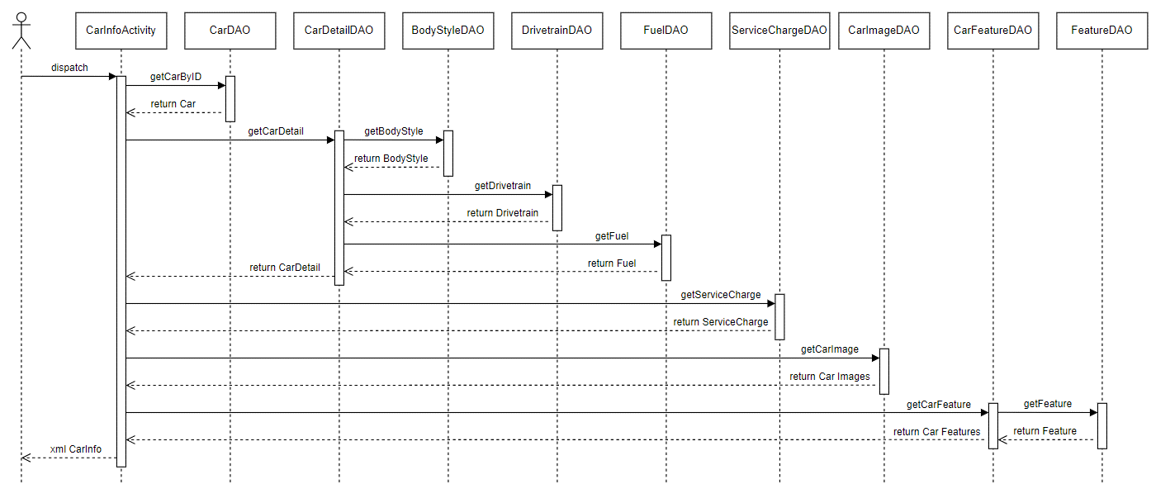

### e. Database queries

*- select * from Car where carID = ?*

*- select * from CarDetail where carID = ?*

*- select * from BodyStyle where bodystyleID = ?*

*- select * from Drivetrain where drivetrainID = ?*

*- select * form Fuel where fuelID = ?*

*- select * from ServiceCharge where carID = ?*

*- select * from CarImage where carID = ?*

*- select * from CarFeature where carID = ?*

*- select * from Feature where featured = ?*

## 3. Add New Car

### a. Class Diagram

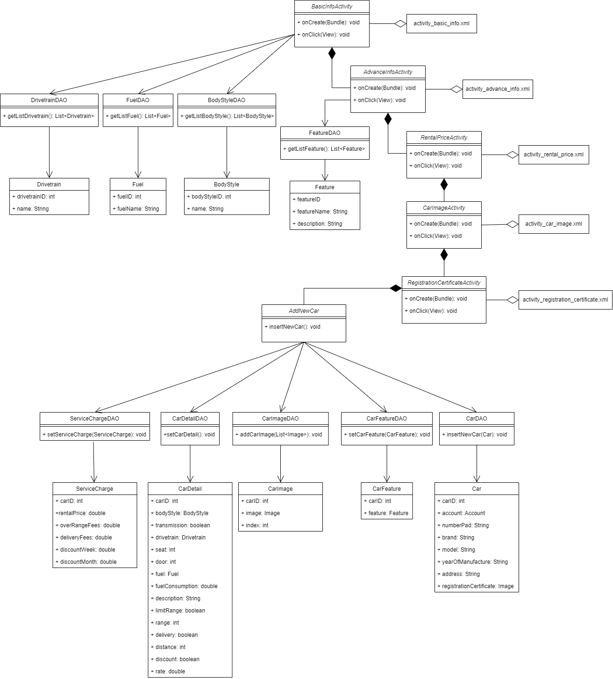

### b. Class Specifications

#### AddNewCar

|  |  |  |
| --- | --- | --- |
| **No** | **Method** | **Description** |
| *01* | *insertNewCar()* | *Insert new car’s information into the database* |
|  |  |  |

#### BasicInfoActivity

|  |  |  |
| --- | --- | --- |
| **No** | **Method** | **Description** |
| *01* | *onCreate()* | *Create graphic user interface* |
| *02* | *onClick()* | *Direct user to next screen* |

#### AdvanceInfoActivity

|  |  |  |
| --- | --- | --- |
| **No** | **Method** | **Description** |
| *01* | *onCreate()* | *Create graphic user interface* |
| *02* | *onClick()* | *Direct user to next screen* |

#### RentalPriceActivity

|  |  |  |
| --- | --- | --- |
| **No** | **Method** | **Description** |
| *01* | *onCreate()* | *Create graphic user interface* |
| *02* | *onClick()* | *Direct user to next screen* |

#### CarImageActivity

|  |  |  |
| --- | --- | --- |
| **No** | **Method** | **Description** |
| *01* | *onCreate()* | *Create graphic user interface* |
| *02* | *onClick()* | *Direct user to next screen* |

#### RegistrationCertifiateActivity

|  |  |  |
| --- | --- | --- |
| **No** | **Method** | **Description** |
| *01* | *onCreate()* | *Create graphic user interface* |
| *02* | *onClick()* | *Direct user to next screen* |

#### DrivetrainDAO

|  |  |  |
| --- | --- | --- |
| **No** | **Method** | **Description** |
| *01* | *getListDrivetrain()* | *Get list of all drivetrains* |
|  |  |  |

#### FuelDAO

|  |  |  |
| --- | --- | --- |
| **No** | **Method** | **Description** |
| *01* | *getListFuel()* | *Get list of all fuel type* |
|  |  |  |

#### BodyStyleDAO

|  |  |  |
| --- | --- | --- |
| **No** | **Method** | **Description** |
| *01* | *getListBodyStyle()* | *Get list of all bodystyle* |
|  |  |  |

#### FeatureDAO

|  |  |  |
| --- | --- | --- |
| **No** | **Method** | **Description** |
| *01* | *getListFeature()* | *Get list of all feature* |
|  |  |  |

#### CarDAO

|  |  |  |
| --- | --- | --- |
| **No** | **Method** | **Description** |
| *01* | *insertNewCar()* | *Insert new car in to the database* |
|  |  |  |

#### ServiceChargeDAO

|  |  |  |
| --- | --- | --- |
| **No** | **Method** | **Description** |
| *01* | *setServiceCharge()* | *Set service charge of the new car in database* |
|  |  |  |

#### CarDetailDAO

|  |  |  |
| --- | --- | --- |
| **No** | **Method** | **Description** |
| *01* | *setCarDetail()* | *Set details information of the new car in database* |
|  |  |  |

#### CarImageDAO

|  |  |  |
| --- | --- | --- |
| **No** | **Method** | **Description** |
| *01* | *addCarImage()* | *Add new car’s images into the database* |
|  |  |  |

### c. Sequence Diagram(s)

*[Provide the sequence diagram(s) for the feature, see the sample below]*

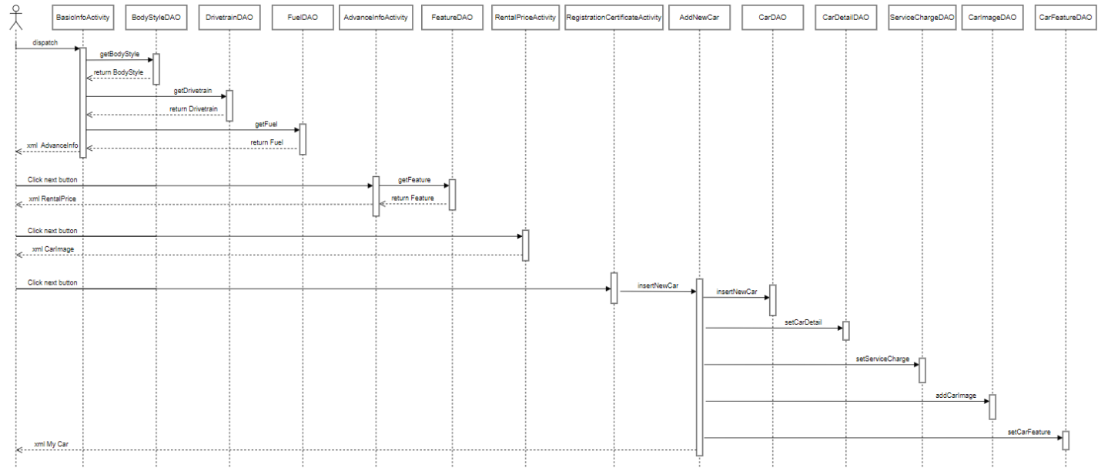

### d. Database queries

*- insert into Car[accountID, number_pad, brand, model, year_of_manufacture, address, registration_certificate] values (?,?,?,?,?,?,?)*

*- insert into CarDetail[carID, body_style, transmission, drivetrain, seat, door, fuel, fuel_consumption, description, limit_range, range, delivery, distance, discount, rate] values (?,?,?,?,?,?,?,?,?,?,?,?,?,?,?)*

*- insert into ServiceCharge[carID, rental_price, over_range_fees, delivery_fees, discount_week, discount_month] values (?,?,?,?,?,?)*

*- insert into CarImage[carID, image, index] values (?,?,?)*

*- insert into CarFeature[carID, featured] values (?,?)*